NATIONAL UNIVERSITY OF SCIENCES AND TECHNLOGY

(DEPARTMENT OF MECHANICAL ENGINEERING)

FUNDAMENTALS OF PROGRAMMING

NAME: Manahil Shahzad

SUBMITTED ON: 10-20-2023

ID: 466695

**TASK 1**

# include <iostream>

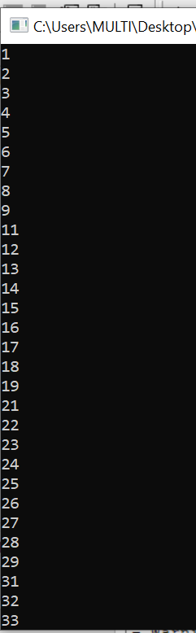

using namespace std ;

int main (){

for (int k = 1; k<= 150 ; k++){

if (k % 10== 0){

continue;

}

cout << k << " "<< endl;

}

return 0;

}

**TASK 2**

# include <iostream>

using namespace std ;

int main (){

int number, digit , sum = 0;

cout << "enter the number you wish to sum"<< endl;

cin >> number ;

while (number>0){

digit= number % 10;

sum+= digit ;

number /= 10 ;

}

cout << "sum of the digit you enter is :"<< sum << endl ;

return 0;

}

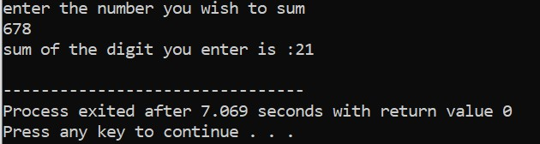

**Task 03**

# include <iostream>

#include <cmath>

using namespace std ;

bool isprime (int num){

if (num <=1 ) {

return false ;

}

if (num ==2){

return true ;

}

if (num % 2==0 ){

return false ;

}

for (int a= 3 ; a<=sqrt(num); a +=2){

return false;

}

return true ;

}

int main () {

int number ;

cout <<"enter a number";

cin >> number ;

if (isprime(number)){

cout <<number << "is a prime number ."<< endl;

}else {

cout << number << "is not a prime number ."<< endl;

}

return 0;

}

